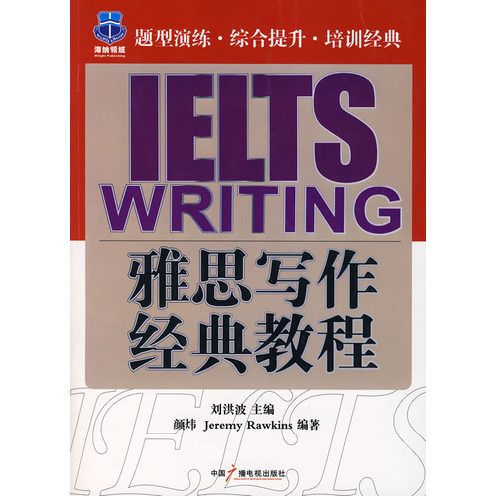
Introduction
IELTS writing classic guide features:
A bilingual writing, effective way to help the candidates to learn the method of writing, the essence of memory Equally listen, highlighting the examination of the practicality.
(2) the choice of subject coverage in recent years, the real exam. Both can be used as a reference of the essay exam can be used to predict the essay exam.
3 Pham Van's writing covers a variety of scores paragraph to help the candidates a thorough understanding of the IELTS writing score, depending on the target step by step.
The book covers the IELTS Writing Class A and Class G variety of subject matter content Pham Van to enable candidates to all-round grasp of the IELTS writing, full of confidence.
Directory
Discussed in one of the first part of the argumentative argumentative classification point of view, two of the table position to discuss the pros and cons to talk about point of view, three of said four personal inclinations analyze the causes and suggestions to talk the text of the assessment methods and Pham Van Review a score of 2 Pham Van examiner reviewed steps Argumentative Writing an essay structure 2 from the questioning approach to problem content to determine the point of view, reason, supports three template sentences - switch topic sentence, support sentences, four of the end of the fourth chapter of the more resources the moonlight clan

